HMU ties with Springfield College are growing stronger. Guest speaker at the postgraduate course "Interdisciplinary Social Interventions in Crisis Situations"

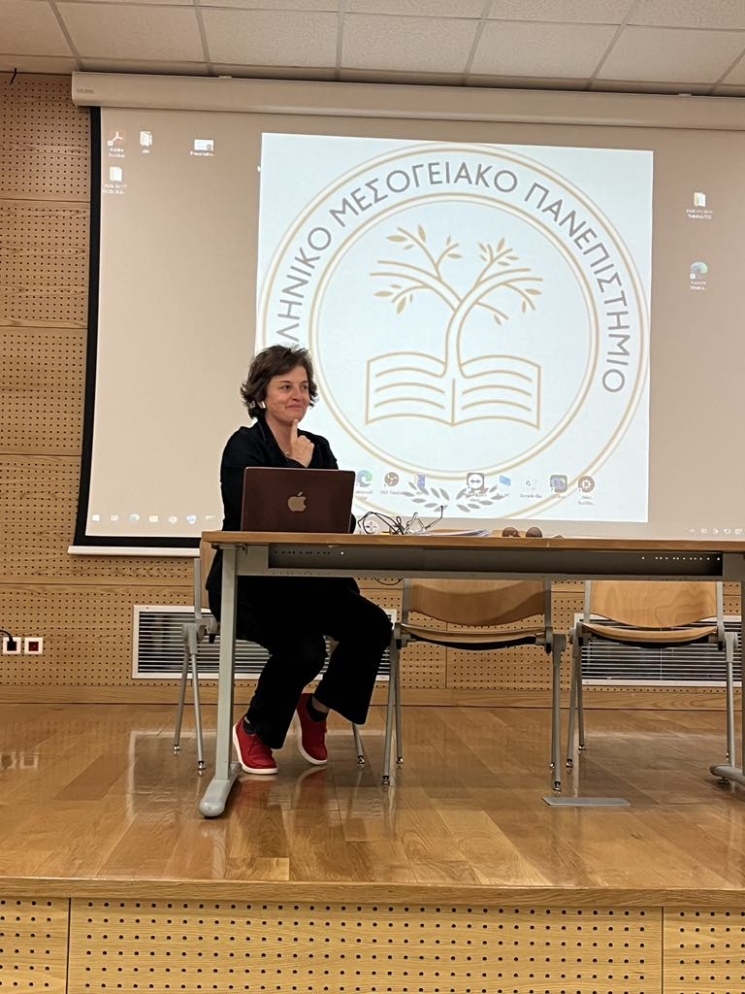

Dr. Effrosyni Kokaliari, Professor of Social Work at Springfield College, USA, and external collaborator of the Laboratory for Applied Social Research and Social Work gave the following lectures in the course "Prevention and Treatment of health and Mental Health issues of Social Work Practice" of the postgraduate program "Interdisciplinary Social Interventions in Crisis Situations”:
- Neurobiology of trauma, attachment, and the somatic imprint. Treating the Soma first. Interventions for clinical social work
- ADHD and its differentiation from trauma. Assessment tools and clinical interventions
- Self-injury and Suicide. Preventive Social Work interventions

Moreover, during her visit she offered a lecture to both undergraduate and postgraduate students of the Department of Social Work regarding the impact of new technologies on Social Work education titled "AI and social work pedagogy. Bringing together excitement diversity and knowledge in the fast-changing classroom".

